2. Execution Context

**STATEMENT** -- Whenever code is run in JS it is run inside of an execution



* Every function() creates a new execution context and it is pushed on to the stack.

**global() execution context**

* Underneath the hood there is a "global() execution context". After every line is read it gets popped off from the stack.
* global() execution context gives us 2 objects, Global object & this object.



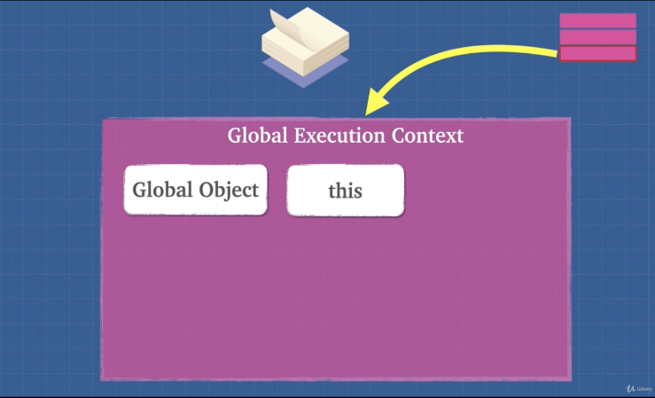

3. Lexical Environment

**Lexical Environment** is simply where we write our code.

**STATEMENT** – Execution context tells us which lexical environment is currently running or which planet is currently running.

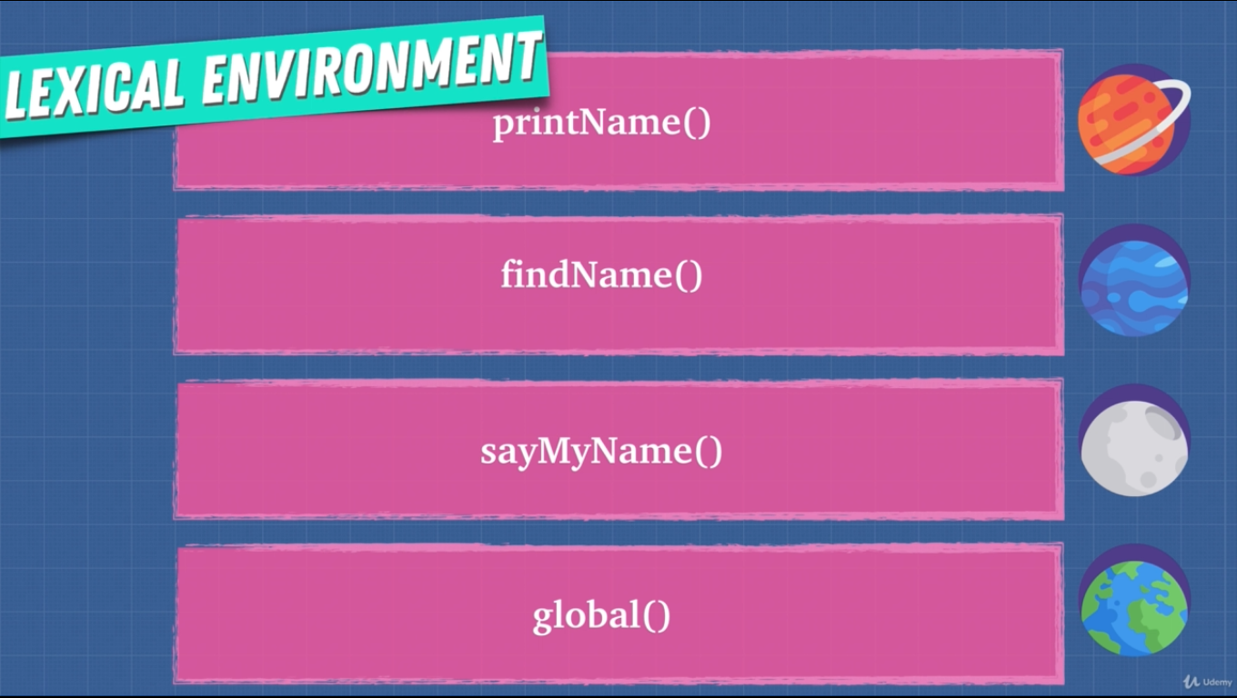

* Every function creates a new lexical environment.
* Lexical scope determines the available data, variables etc. not where the function is called.

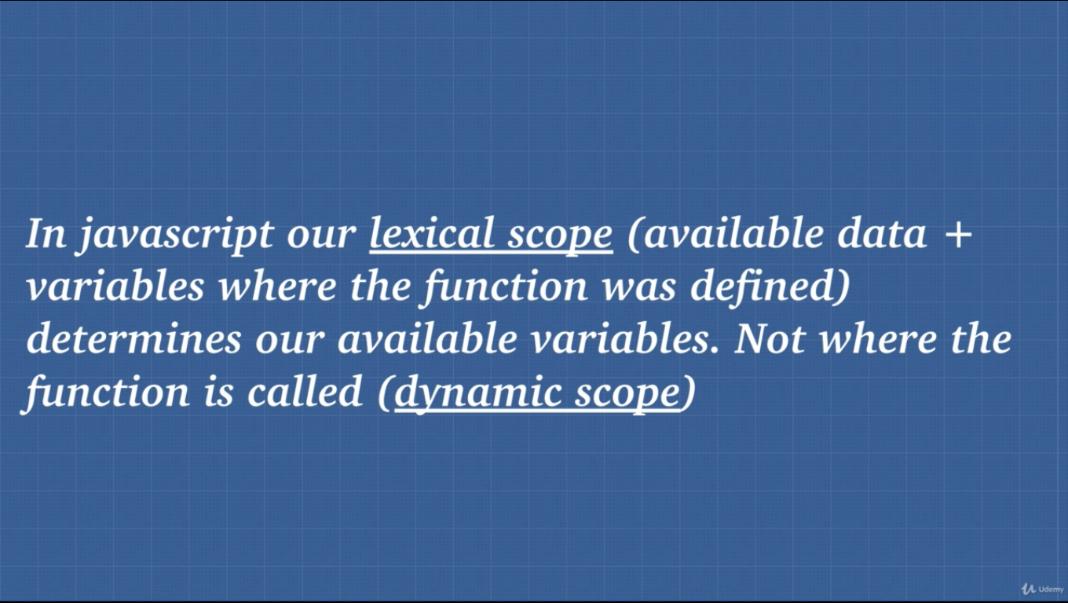

4. Hoisting

**Hoisting**: Hoisting is moving the var or function declaration to the top of their respective environment during compilation phase.

Caution: Try not to use hoisting as it makes code unpredictable.

Use const and let keyword.

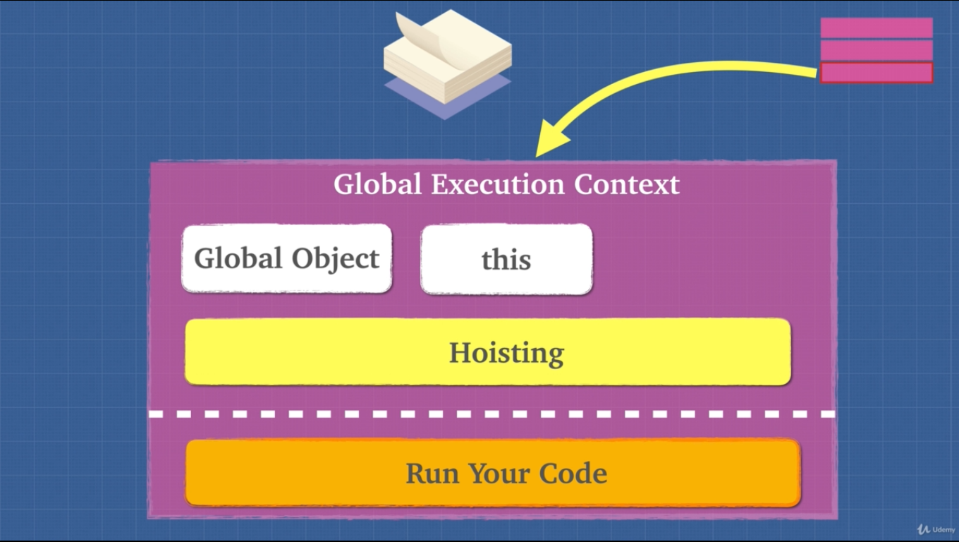

* Hoisting is unique only to javascript.
* var and function expression is partially hoisted and function declaration is hoisted.

5. Exercise Hoisting

* For var hoisting ignores same variable name if found, only takes the first one because it is partially hoisted.
* For function, hoisting happens fully. If same function is found it overrides the previous function in memory.

6. Exercise Hoisting 2

* When we run a function a new execution context is created.

function() {

Here is a new execution context.

}

**STATEMENT** – Hoisting is bad practice. We can avoid hoisting using “const” or “let”.

8. Function Invocation

Function invocation/Call/Execution are the same thing

foo()

* Function expression is defined at runtime.
* Function declaration is defined at parse time (reading the code and allocating memory).

function() {

Here is a new execution context.

We get this and arguments objects.

}

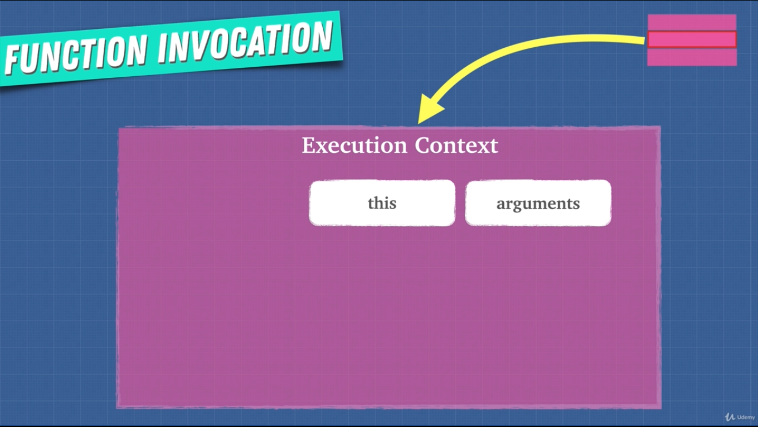

9. arguments Keyword

* Using arguments is bad practice. JS engine or compiler may not be able to optimize our code.
* arguments is not really an array, it’s an object.
  + Work around to this is



* + Or using spread operator and args (…args)

10. Variable Environment

* Variable inside of a function or execution context/little universes.

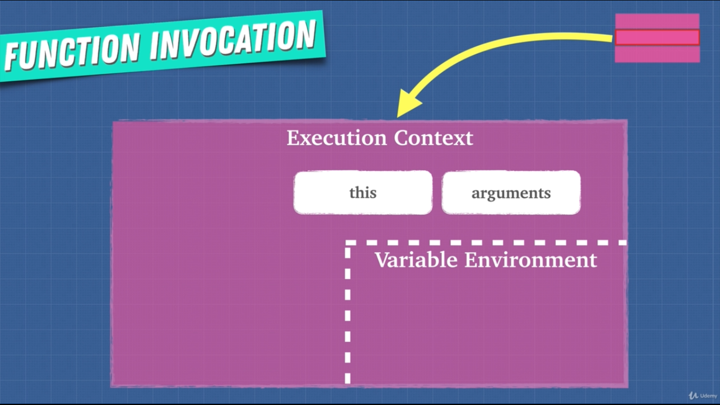

* On a new execution context/world their own variable will only work in their world/execution context.
* Whenever any function/execution context is popped from the stack their variable will also be removed.
* Reference variable and stuff will be in future lessons.

11. Scope Chain

* Each context has a link to its outside world/parent.
* Outer environment/world is defined where the function sits lexically. We may call a function in another function but that doesn’t mean that we can access their variable, again it is defined lexically.
* **Scope chain** gives us access to the parent environment.
* Function firstly looks for any variable inside its own variable environment if it doesn’t find any value then it looks at the parent environment.



(Lexical scope or static scope)

* Lexical scope in a language means that only looking at the source code we can determine which environment the variables and data are available.
* Children has ink to all the ancestors.

12. [[scope]]

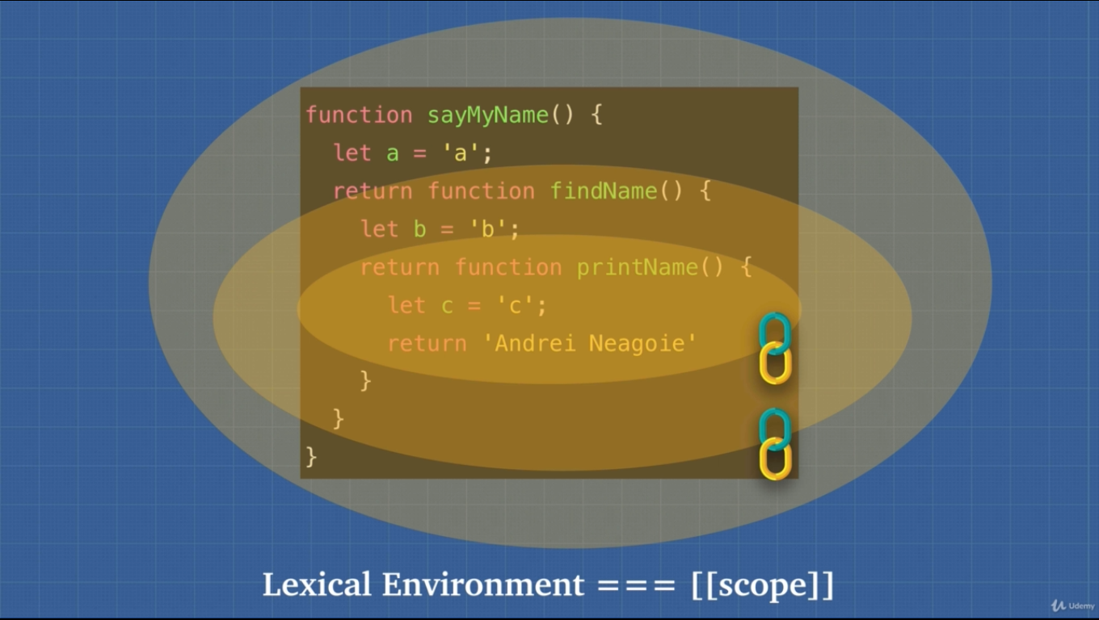

13. Exercise JS is Weird

* We cannot use function expression with its function name. It’ll throw a reference error. It is enclosed in its own scope 😐. It is added to its own execution context variable environment 😐.

14. Function Scope vs Block Scope

* Scope means what variable we have access to.
* Previously JS has functional scope using that var ☹ keyword. Now with the introduction of const 😊 and let 😊 in ES6 we can use blocked scope.
* In functional scope we could use other scoped variables 😐.
* With blocked scope variable remains to its own scope nowhere else.

16. Global Variables

* Using global variable is bad practice. We should avoid using global variable.
* Variable collision may occur as web pages pack all the script files and run them on a global execution context.
* Memory heap can be filled with data. Browser gets slower.

17. IIFE

(immediately invoked function expression)



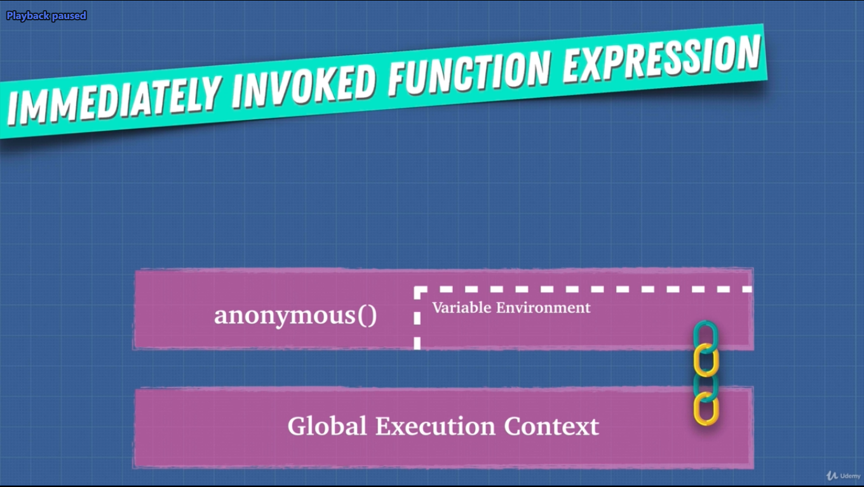

* Function expression has its own variable environment and it can be accessed by the global execution context.
* It pollutes global environment once. It’s like a parent function.
* We can get the jQuery object in the global context (as jQuery uses IIFE, it returns the jQuery object). If we use this object as the parameter for function expression then our IIFE will also get all the goodness of the jQuery object.
* As we are not going to the global name space to find the object, we are gaining a performance boost. Function is only looking at the local scope.

18. this Keyword

**STATEMENT** – This is the object that the function is a property of.

“this refers to whatever is to the left of the dot” – Andre.

Left of the dot is this object.

* Method of an object is a function. Method is a function inside of an object.
* this refers to the window object at the global name space. (sometimes it can cause problems with unwanted behavior.)

Why this:

1. this gives methods access to their object.
2. Executes same code for multiple objects.

We can think this as who called me?

19. Exercise Dynamic Scope vs Lexical Scope

* Whatever is left of the dot refers to this. If nothing is to the left then it is window object even if the function is called from anywhere.
* this keyword is not lexically scoped. It only matters how the function is called.
* In JS this keyword defaults to the window object.
* this keyword is dynamically scoped only exception. Others are lexically scoped.
* In order to make it consistent ES6 arrow function (=>) made this keyword behave like lexically scoped.
* (!important) Previously programmers used to return this with .bind. And called the function multiple times.
* Another way was to reference this in a variable and using that variable. That variable is inside the object when it is run.

20. call(), apply(), bind()

* Underneath the hood all functions use call() when invoking a function.
* When we do foo() what we are actually doing is foo.call()
* Call() and apply() are the same things. We use them to borrow methods from another object. Only difference is that call() takes multiple arguments and apply() takes an array of argument.
* bind() does not run the function right away instead it returns a function. bind() allows us to store this keyword or function borrowing for later use.
* bind() is useful for us to call functions later on with a certain context or certain this keyword.

22. bind() and currying

* Currying: Using bind() we reuse a function and give a partial parameter among multiple parameters and when we use that function, we give remaining parameter.

23. Exercise this Keyword

* If this is inside of an object then this represent the object.
* If this is inside of a nested method then it represent window object (dynamically scoped).

25. Context vs Scope

* Scope is function based thing.
  + What is in the variable environment.
* Context is more of an object-based thing.
* What’s the value of the this keyword.